# JWT HandsOn

**Create authentication service that returns JWT**

**Implementation:**

1. **Create AuthenticationController.java**

com.cognizant.spring_learn.controller

package com.cognizant.spring_learn.controller;

import com.cognizant.spring_learn.util.JwtUtil;

import org.slf4j.Logger;

import org.slf4j.LoggerFactory;

import org.springframework.web.bind.annotation.*;

import java.util.Base64;

import java.util.HashMap;

import java.util.Map;

@RestController

public class AuthenticationController {

private static final Logger LOGGER = LoggerFactory.getLogger(AuthenticationController.class);

private final JwtUtil jwtUtil;

// Inject JwtUtil

public AuthenticationController(JwtUtil jwtUtil) {

this.jwtUtil = jwtUtil;

}

@GetMapping("/authenticate")

public Map<String, String> authenticate(@RequestHeader("Authorization") String authHeader) {

LOGGER.info("START - /authenticate");

LOGGER.debug("Authorization Header: {}", authHeader);

String user = getUser(authHeader);

String token = jwtUtil.generateToken(user);

Map<String, String> response = new HashMap<>();

response.put("token", token);

LOGGER.info("END - /authenticate");

return response;

}

private String getUser(String authHeader) {

String base64Credentials = authHeader.substring("Basic".length()).trim();

byte[] decodedBytes = Base64.getDecoder().decode(base64Credentials);

String decoded = new String(decodedBytes);

String[] parts = decoded.split(":", 2);

return parts[0];

}

}

1. **SecurityConfig.java**

com.cognizant.spring_learn.config

package com.cognizant.spring_learn.config;

import org.springframework.context.annotation.Bean;

import org.springframework.context.annotation.Configuration;

import org.springframework.security.config.annotation.web.builders.HttpSecurity;

import org.springframework.security.core.userdetails.User;

import org.springframework.security.core.userdetails.UserDetailsService;

import org.springframework.security.provisioning.InMemoryUserDetailsManager;

import org.springframework.security.web.SecurityFilterChain;

import org.springframework.security.crypto.password.NoOpPasswordEncoder;

import org.springframework.security.crypto.password.PasswordEncoder;

@Configuration

public class SecurityConfig {

@Bean

public UserDetailsService userDetailsService() {

InMemoryUserDetailsManager manager = new InMemoryUserDetailsManager();

manager.createUser(User.withUsername("user").password("pwd").roles("USER").build());

manager.createUser(User.withUsername("admin").password("admin").roles("ADMIN").build());

return manager;

}

@Bean

public PasswordEncoder passwordEncoder() {

return NoOpPasswordEncoder.getInstance(); // For demo only

}

@Bean

public SecurityFilterChain filterChain(HttpSecurity http) throws Exception {

http.csrf(csrf -> csrf.disable())

.authorizeHttpRequests(auth -> auth

.requestMatchers("/countries").hasRole("USER")

.requestMatchers("/authenticate").hasAnyRole("USER", "ADMIN")

.anyRequest().authenticated()

)

.httpBasic();

return http.build();

}

}

1. **Pom.xml**

<?xml version="1.0" encoding="UTF-8"?>

<project xmlns="http://maven.apache.org/POM/4.0.0" xmlns:xsi="http://www.w3.org/2001/XMLSchema-instance"

xsi:schemaLocation="http://maven.apache.org/POM/4.0.0 https://maven.apache.org/xsd/maven-4.0.0.xsd">

<modelVersion>4.0.0</modelVersion>

<parent>

<groupId>org.springframework.boot</groupId>

<artifactId>spring-boot-starter-parent</artifactId>

<version>3.5.3</version>

<relativePath/> <!-- lookup parent from repository -->

</parent>

<groupId>com.cognizant</groupId>

<artifactId>spring-learn</artifactId>

<version>0.0.1-SNAPSHOT</version>

<name>spring-learn</name>

<description>Demo project for Spring Boot</description>

<url/>

<licenses>

<license/>

</licenses>

<developers>

<developer/>

</developers>

<scm>

<connection/>

<developerConnection/>

<tag/>

<url/>

</scm>

<properties>

<java.version>17</java.version>

</properties>

<dependencies>

<dependency>

<groupId>org.springframework.boot</groupId>

<artifactId>spring-boot-starter-web</artifactId>

</dependency>

<dependency>

<groupId>org.springframework.boot</groupId>

<artifactId>spring-boot-devtools</artifactId>

<scope>runtime</scope>

<optional>true</optional>

</dependency>

<dependency>

<groupId>org.springframework.boot</groupId>

<artifactId>spring-boot-starter-test</artifactId>

<scope>test</scope>

</dependency>

<dependency>

<groupId>javax.xml.bind</groupId>

<artifactId>jaxb-api</artifactId>

<version>2.3.1</version>

</dependency>

<dependency>

<groupId>io.jsonwebtoken</groupId>

<artifactId>jjwt</artifactId>

<version>0.9.1</version>

</dependency>

<dependency>

<groupId>org.springframework.boot</groupId>

<artifactId>spring-boot-starter-security</artifactId>

</dependency>

<dependency>

<groupId>io.jsonwebtoken</groupId>

<artifactId>jjwt-api</artifactId>

<version>0.11.5</version>

</dependency>

<dependency>

<groupId>io.jsonwebtoken</groupId>

<artifactId>jjwt-impl</artifactId>

<version>0.11.5</version>

<scope>runtime</scope>

</dependency>

<dependency>

<groupId>io.jsonwebtoken</groupId>

<artifactId>jjwt-jackson</artifactId> <!-- or jjwt-gson if you prefer -->

<version>0.11.5</version>

<scope>runtime</scope>

</dependency>

</dependencies>

<build>

<plugins>

<plugin>

<groupId>org.springframework.boot</groupId>

<artifactId>spring-boot-maven-plugin</artifactId>

</plugin>

</plugins>

</build>

</project>

1. **application.properties**

spring.application.name=spring-learn

server.port=8081

logging.level.root=DEBUG

logging.level.root=INFO

spring.devtools.restart.enabled=true

logging.pattern.console=%d{yyMMdd}|%d{HH:mm:ss.SSS}|%-20.20thread|%5p|%-25.25logger{25}|%25M|%m%n

spring.security.user.name=user

spring.security.user.password=pwd

spring.profiles.active=jwt

1. **JwtUtil.config**

com.cognizant.spring_learn.util

package com.cognizant.spring_learn.util;

import io.jsonwebtoken.Jwts;

import io.jsonwebtoken.SignatureAlgorithm;

import org.springframework.stereotype.Component;

import java.util.Date;

@Component

public class JwtUtil {

private final String SECRET_KEY = "secret";

public String generateToken(String username) {

return Jwts.builder()

.setSubject(username)

.setIssuedAt(new Date(System.currentTimeMillis()))

.setExpiration(new Date(System.currentTimeMillis() + 1000 * 60 * 60)) // 1 hour

.signWith(SignatureAlgorithm.HS256, SECRET_KEY)

.compact();

}

}

1. **SpringLearnApplication.java**

package com.cognizant.spring_learn;

import org.slf4j.Logger;

import org.slf4j.LoggerFactory;

import org.springframework.boot.SpringApplication;

import org.springframework.boot.autoconfigure.SpringBootApplication;

import org.springframework.context.ApplicationContext;

import org.springframework.context.annotation.ImportResource;

import org.springframework.context.support.ClassPathXmlApplicationContext;

@ImportResource("classpath:country.xml")

@SpringBootApplication

public class SpringLearnApplication {

private static final Logger LOGGER = LoggerFactory.getLogger(SpringLearnApplication.class);

public static void main(String[] args) {

LOGGER.debug("START - main()");

SpringApplication.run(SpringLearnApplication.class, args);

LOGGER.debug("END - main()");

}

}

**Output:**

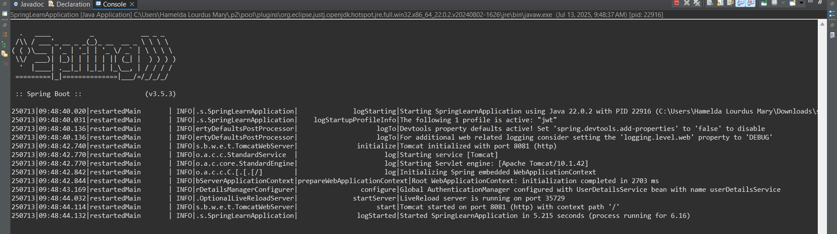

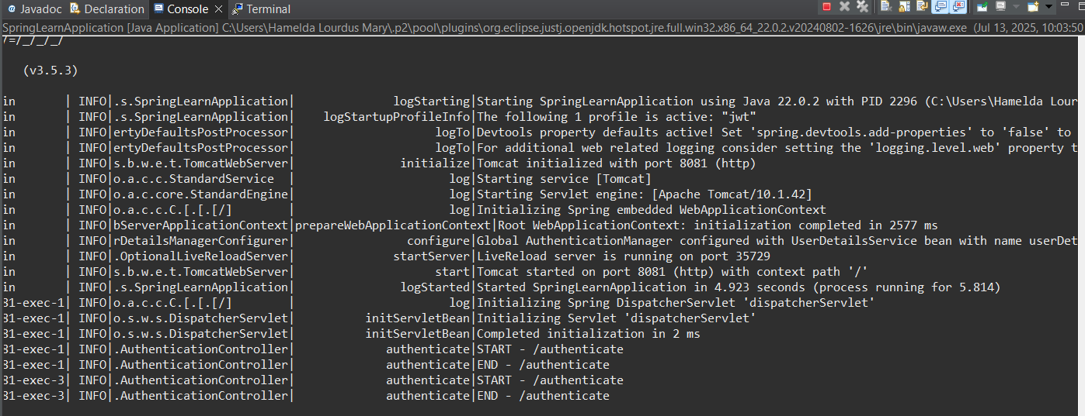

**Testing:**

curl -s -u user:pwd http://localhost:8081/authenticate

**Output:**

**Terminal:**

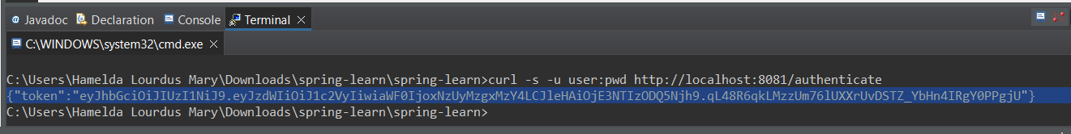

**Postman:**

